**Formatting Data in Excel to Use in Tableau Public**

**PITTSBURGH DATA JAM**

1. **Dimensions vs. measures**

Tableau separates information in two ways, dimensions and measures. This separation makes graphing and visualizing data easer later on. When formatting your Data in excel keep this in mind and prepare to recognize the difference.

* + Our “dimensions” are what we would think of as headings. Dimensions are what we are measuring with our data.
  + Our “measures” are the data we were given or collected. Measures describe our dimensions, and are most commonly in the form of numbers.
  + For example, Things like countries and states are dimensions, where as the population of those countries and states are measures.

1. **Rows and columns**

Sometimes data sets that are given to you are formatted in a way that is easy to read, however will not transfer into Tableau Public very well. One common problem is column and row format.

* Data sets that are given to you may have columns with headings and subheadings. To transfer data like this over, we have to create a new column for every subheading.
  + Notice the figure below, the first column is broken up into sub-headings: state, institution type (public or private), and institution name. The headings are moved into their own column. This allows Tableau to track each dimensions separately, and will lead to better working in Tableau.

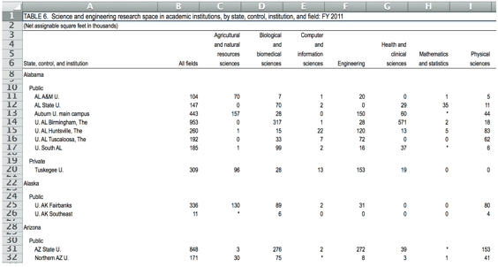

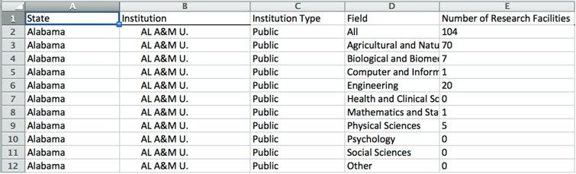

1. **Dates**

Dates in excel may seem straight forward, however Tableau might have trouble understanding what they are. If you are using a date or time as a part of your data, edit the cell so that Tableau can read it.

* + Right click cell 🡪 format cells 🡪 category 🡪 Date 🡪 chose date type

1. **Transferring to Tableau Public**

Once your data is formatted correctly in excel, transferring it to Tableau public should be easy.

* + Save your Excel workbook, and open Tableau Public.
  + Follow the prompts to transfer data.
  + If it looks like tableau public is not reading your data correctly try using Tableau’s data interpreter.

**For more detailed info, refer to the data jam manual.**